**NAME: MAHNOOR QAZI**

**R.NO: FA21-BSE-020**

**SECTION: BSE 4A**

**LAB MID**

**MAIN SUCCESS SCENARIO:**

**Approve meter installation:**

**User**

**Main success scenario of approve meter installation by SDO**

**MAIN SUCCESS SCENARIO:**

The main success scenario of an approved meter installation by a (SDO) typically follows these steps:

|  |  |  |
| --- | --- | --- |
| STEP | ACTION | SYSTEM RESPONSE |
| 1 | SDO receives the meter installation request. | The system acknowledges the request and assigns a unique request ID. |
| 2 | SDO reviews the request for meter installation. | The system verifies the completeness and validity of the request. |
| 3 | SDO validates the requested meter installation details | The system checks if the requested meter details conform to the system policies. |
| 4 | SDO approves the meter installation. | The system updates the status of the meter installation request to "Approved". |
| 5 | SDO notifies the customer about the approval. | The system sends a notification to the customer confirming the approval. |
| 6 | SDO updates the meter inventory. | The system adds the approved meter to the inventory for installation. |
| 7 | SDO generates a work order for meter installation. | The system creates a work order with installation details for the field team. |

**SSD:**

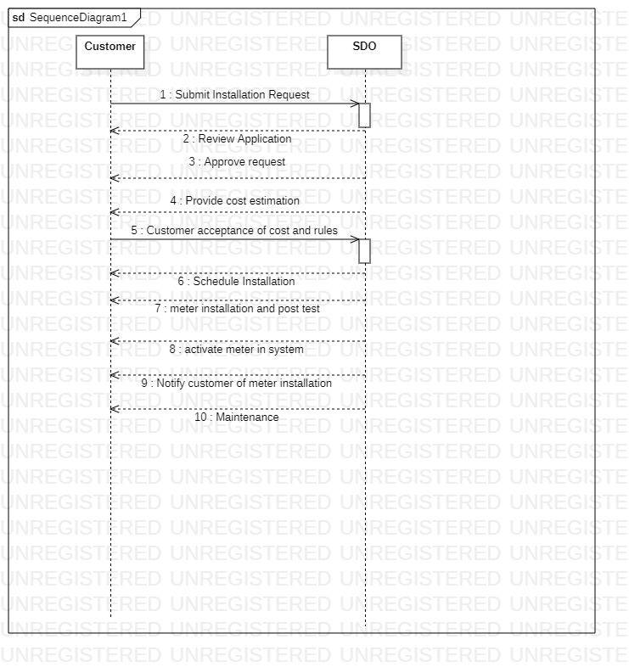

**PROTOTYPE:**

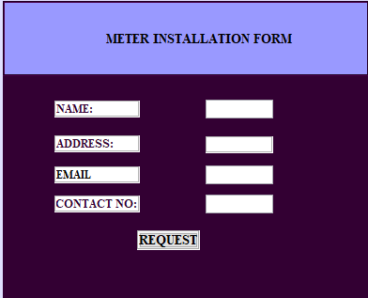

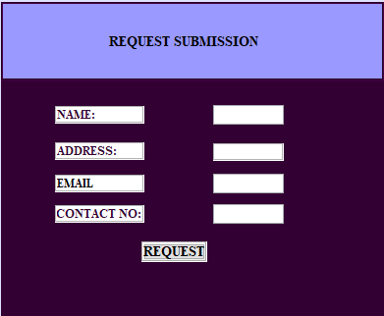

When the user clicks on request he goes on the functionality page:

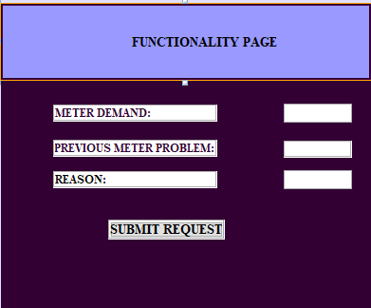

SDO will review and accept and request.

